**Relational Model Checkpoint**

**Relationship Model**

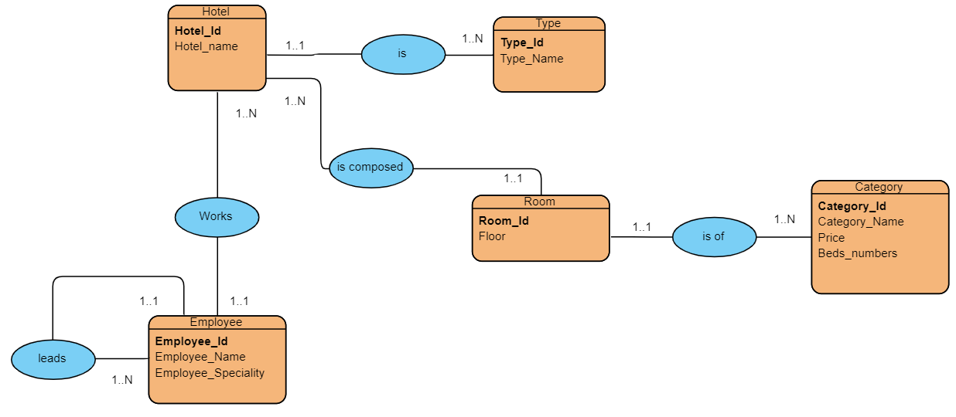

**Relational Diagram**

Hotel (**Hotel_id** , Hotel_name ,**#Type_id** )

Type (**Type_id ,** Type_name)

Employee (**Employee_id** , Employee_Name , Employee_Speciality , **#Hotel_id**, **#leader_id** )

Room ( Room_id,Floor , #Hotel_id , #Category_id)

Category (**Category_id** , Category_Name , Price , Beds_numbers)